FarmGame rulebook

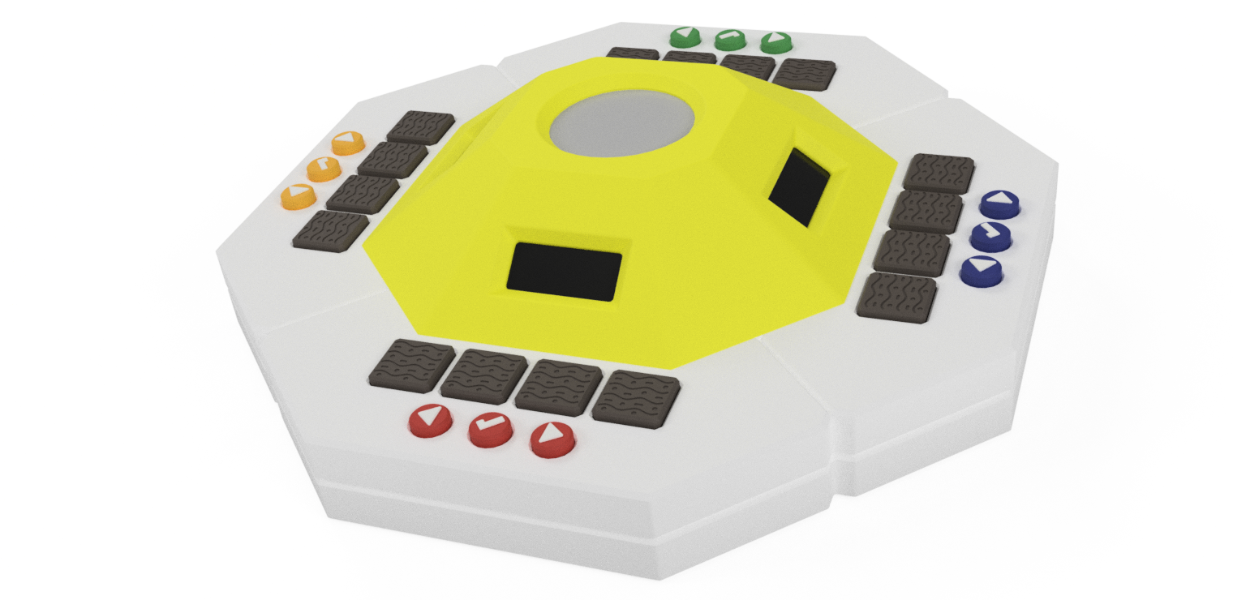

Welcome to Farm Game!
Step into the boots of a farmer and compete with friends in this exciting agricultural challenge! You'll plant crops, manage unpredictable weather, and race to harvest at the perfect time to score the most points. Will you play it safe with quick-growing corn, or risk it all on precious blueberries?

Getting Started

Starting the Game
1. Turn on your device and watch the "FARM GAME" logo appear
2. Player 1 can either:
  - Press CONFIRM to go to player selection
  - Hold BACK for 2 seconds to access settings

Player Selection (10 seconds)
- Each player presses CONFIRM to join the game
- You need at least 2 players to start (maximum 4)
- If there are not enough players, the game will continue waiting until more players join

Controls and Display

Your Controls
- BACK: Navigate left / Decrease value
- FORWARD: Navigate right / Increase value
- CONFIRM: Select / Confirm action

Game Display

The Main Screen (Center)
Your central game view showing:
- Colored border: Shows whose turn it is
- Crop images: See what's growing in each field
- Field status: Empty fields, growing crops, or ready-to-harvest crops

Your Personal Screen (OLED)
Each player gets their own information display:
- Current score
- Field status and crop information
- Weather effects and menus
- Turn-specific information

Field Status Lights (LEDs)
16 colorful lights around the device showing everyone's field status:
- Gray lights: Empty fields
- Colored lights: Growing crops (each crop has its own color)
- Dark lights: Player not in the game

Your Crops
Every crop has different growing times and point values. Some grow fast but give fewer points, others take longer but reward your patience!

Crop | Turns to Grow | Simple Mode | Medium Mode | Advanced Mode
Corn 🌽 | 2 turns | 1 point | 2 points | 3 points
Carrot 🥕 | 3 turns | 4 points | 5 points | 6 points
Tomato 🍅 | 4 turns | 8 points | 9 points | 12 points
Lettuce 🥬 | 5 turns | 15 points | 16 points | 20 points
Blueberry 🫐 | 6 turns | 20 points | 25 points | 30 points

Crop Characteristics
- Corn: Quick and reliable, but modest points
- Carrot: Decent growing time with fair rewards
- Tomato: Takes patience but pays reasonably well
- Lettuce: Premium crop with good returns for the wait
- Blueberry: High maintenance and risky, but potentially the most rewarding!

How to Play

1. Weather Phase ☀️🌧️🏜️
Every turn starts with checking the weather:
1. The active player presses CONFIRM to reveal the weather
2. Watch the weather animation on the main screen
3. Check your personal screen to see how the weather affects each of your crops:
  - Field number and crop name
  - Weather effect symbol (X, ?, +, ++, +++)
4. Press CONFIRM when ready to continue

Weather Types:
- Sunny ☀️: Generally good for crop growth
- Rain 🌧️: Some crops love it, others just get normal growth
- Drought 🏜️: Tough conditions - most crops struggle

2. Harvest and Plant Phase
Now you manage your 4 fields:
1. Use BACK/FORWARD to navigate between your fields (F1-F4) or "End Turn"
2. Quick tip: Hold FORWARD for 1 second to jump directly to "End Turn"
3. Press CONFIRM on any field to:
  - Empty field: Plant a new crop (if allowed)
  - Ready crop: Harvest and earn points
  - Growing crop: Nothing happens (you'll hear a beep)
  - End Turn: Confirm twice to finish your turn

When you harvest:
- Points appear in your player color
- Your score updates immediately
- The field becomes empty and ready for new crops

3. Planting Phase (when you select an empty field)
1. Browse available crops with BACK/FORWARD
2. Your screen shows the crop name, main screen shows turns and points
3. Press CONFIRM to plant the selected crop
4. Return to field management

4. End of Turn
- Weather effects are applied to all your growing crops
- Next player takes their turn
- Game continues until all rounds are complete

Game Modes
Choose your difficulty level! Each mode offers different weather mechanics and point values.

SIMPLE Mode - "Learning the Basics"
Weather Effects:
- Drought: No growth for any crops
- Rain: 50% chance each crop will grow (random)
- Sun: Normal growth for all crops

Best for: New players learning the game. Weather is unpredictable, so focus on understanding crop timing.

MEDIUM Mode - "Balanced Challenge"
Weather Effects:
- Drought: No growth for any crops
- Rain: Double growth for all crops (-2 turns)
- Sun: Normal growth for all crops (-1 turn)

Best for: Players who want predictable weather patterns. Rain becomes very powerful for everyone.

ADVANCED Mode - "Strategic Farming"
Weather Effects:
Each crop reacts differently to weather conditions:

Weather | Corn 🌽 | Carrot 🥕 | Tomato 🍅 | Lettuce 🥬 | Blueberry 🫐
Drought | 80% chance normal growth | No growth | No growth | No growth | No growth
Sun | Double growth (-2 turns) | Normal growth | Double growth (-2 turns) | Normal growth | Normal growth
Rain | Normal growth | Double growth (-2 turns) | Normal growth | Double growth (-2 turns) | Double growth (-2 turns)

Weather Effect Symbols:
- X = No growth / Stale crop
- ? = Chance-based growth (80% for corn in drought)
- + = Normal growth (-1 turn)
- ++ = Double growth (-2 turns)

Advanced Mode Special Rules:

Stale Crops:
- Crops left unharvested too long will spoil and lose value
- Stale crops show "STALE" in red and give only 25% points
- You must harvest quickly or watch your crops deteriorate!

Planting Limit:
- You can only plant 2 crops per turn (not total - per turn!)
- Your screen shows "Planted:X/2" to track your progress
- Empty fields show "X" when you've reached your limit
- Choose your plantings wisely each turn!

Best for: Experienced players who enjoy strategic depth. Match crops to expected weather, harvest quickly to avoid spoilage, and plan your limited plantings carefully.

Settings Menu

Accessing Settings
From the start screen, Player 1 holds BACK for 2 seconds to enter the settings menu.

Available Settings

1. LED Brightness
- Options: 0%, 25%, 50%, 75%, 100%
- Default: 50%
- What it does: Adjusts how bright the status lights shine
- The lights turn on when you enter this setting

2. Number of Rounds
- Options: 5, 10, 15, or 20 rounds
- Default: 10 rounds
- What it does: Sets how many turns each player gets

3. Menu Sounds
- Options: ON / OFF
- Default: ON
- What it does: Toggle the helpful beeps and navigation sounds

4. Battery Info
- Display: Shows battery voltage and remaining power
- What it does: Monitors your device's power supply (if battery sensor is connected)
- Color coding: Green (good), Orange (low), Red (very low)
- Note: Information only - you can't change this setting

5. Weather System
- Options: SIMPLE / MEDIUM / ADVANCED
- Default: SIMPLE
- What it does: Changes how weather affects crops and determines point values

6. Exit Settings
- Action: Saves all settings and returns to player selection
- Your settings are remembered when you power off the device

Using Settings
- BACK/FORWARD: Navigate between settings
- CONFIRM: Enter adjustment mode
- While adjusting:
  - BACK/FORWARD: Change the value
  - CONFIRM: Save and exit adjustment mode

Winning the Game

Scoring
Your score increases each time you harvest a ready crop. Point values depend on the crop type and which game mode you're playing (see the crop table above).

Game End
- The game ends after everyone completes their set number of rounds
- Victory music plays (a triumphant C-E-G-C fanfare)
- The winner's status lights pulse three times in celebration
- The player with the highest score wins
- If there's a tie: Multiple winners share the victory with "TIE!" displayed

Victory Screen:
- Main Screen: Shows the winner's name with their color, plus complete rankings of all players
- Winner's Screen:
  - Displays "YOU WON!" or "TIED!" in the center
  - Shows "Press CONFIRM" to start a new game
  - Only winners can start the next game
- Other Players' Screens:
  - Shows their final ranking and total score
  - Must wait for the winner to decide on starting a new game

Tips & Strategy

General Strategy
1. Quick crops (like corn) are safe bets but give fewer points
2. Slow crops (like blueberries) are risky investments but can pay off big
3. Keep an eye on weather patterns - they come from a limited "bag" of possibilities
4. Don't put all your eggs in one basket - diversify your fields

Understanding Weather Patterns
Weather isn't completely random! It comes from a "weather bag" containing:
- 4 Sunny days
- 3 Rainy days
- 4 Drought days

Once all 11 weather cards are used, the bag refills. Smart players track what's been drawn to predict what's coming next!

Mode-Specific Tips
Simple Mode:
- Focus on learning crop timing rather than weather prediction
- Plant a mix of fast and slow crops to spread your risk
- Weather is mostly unpredictable, so don't rely on it too much

Medium Mode:
- Plant slower crops before expected rain for maximum benefit
- Rain helps everyone equally, so timing is everything
- Drought is your enemy - harvest quickly when you see it coming

Advanced Mode:
- Match crops to weather:
  - Plant corn before sun or drought (it's tough and loves sun)
  - Plant tomatoes before sunny weather
  - Plant carrots and lettuce before rain
  - Plant blueberries before rain (they love it - 30 points!)
- Harvest immediately when crops are ready - spoilage costs you 75% of your points!
- Plan your 2 plantings per turn carefully - prioritize high-value crops
- Track the weather bag - with 4 droughts, 3 rains, and 4 sunny days, drought is most common

Field Management
- Keep crops at different growth stages so you always have something ready
- Never leave all fields empty (unless you've hit your planting limit in Advanced mode)
- In Advanced mode, sometimes harvesting is more important than planting
- Time-saving tip: Hold FORWARD for 1 second to quickly jump to "End Turn"

Player Colors
- Player 1: Red
- Player 2: Yellow
- Player 3: Green
- Player 4: Blue

Ready to Play?
Now you know everything you need to become a farming champion! Start with Simple mode to learn the basics, then challenge yourself with Medium and Advanced modes.

Whether you're growing reliable corn or precious blueberries, every choice matters. Good luck, and may the best farmer win! 🌾

Technical Information

Hardware Requirements
- ESP32-S3 microcontroller
- GC9A01 240x240 TFT display
- 4x SSD1306 128x64 OLED displays
- WS2812B LED ring (16 LEDs)
- PCF8575 I/O expander for buttons
- MAX17048 battery fuel gauge (optional)
- Buzzer for sound effects

Display Layouts
TFT Screen:
- Colored ring showing active player
- Center area: crop images, field status, weather
- Score display during status updates

OLED Screens:
- Player-specific information
- Field selection menus
- Crop selection menus
- Weather effects summary
- Turn status

Troubleshooting

Game Won't Start
- Ensure at least 2 players press CONFIRM during player selection
- Check that all displays are connected

No Sound
- Check Menu Sounds setting (may be OFF)
- Verify buzzer connection

Battery Shows "Sensor not found"
- MAX17048 sensor not detected or not connected
- Game still playable without battery monitoring

LEDs Not Working
- Check LED Brightness setting (may be 0%)
- Verify LED ring connection

Credits
Farm Game - A competitive multiplayer farming experience with strategic weather mechanics and crop management.

